# Science – Curriculum Policy

School Drivers

Our four school drivers will be shown in our Science curriculum by:

* Core Skills
* Oracy: *the children will learn key technical vocabulary, they will discuss their observations, reasons for classifications and results of their tests.*
* Writing: *the children will write about their findings from research and experiments.*
* Reading: *the children will research scientific findings and scientists to inform their learning.*
* Maths: *the children will discuss measurements and findings from experiments.*
* Character

The children will demonstrate all their character muscles throughout our science curriculum. The most prevalent ones being questioning, curiosity, enthusiasm and communication.

* Cultural Capital

The children will develop their cultural capital by learning about different scientists, and scientific findings. They will get the opportunity to take part in enrichment activities with an emphasis on science including the trip to the Think Tank.

* Citizenship

The children’s citizenship will be developed in our science curriculum through understanding what impact scientific discoveries have on society. They will also develop their concept of global citizenships by learning about scientists from around the world.

Intent

“We will provide all of our children with a *broad, relevant* and *enriched* curriculum so that they have the *character* to make a *positive* contribution to our society and are *knowledgeable, skilled and ready* for the next phase of their education.”

Science stimulates enquiry and problem solving. It provides practical experiences, and a unique way of understanding and responding to the world. It enables children to understand how the world around them works. Children have the opportunity to classify and observe the natural world. They learn to ask questions, test hypothesis and control variables in practical experiments.

We aim to ensure that all pupils are:

* able to record from first-hand experience and observations
* ask questions about the world around them
* to select their own ideas to test
* develop their ability to control materials, tools and techniques
* develop increasing confidence to conduct scientific research
* foster an enjoyment and appreciation of scientific study
* develop an understanding of the work of some leading scientists
* able to develop the scientific skills and knowledge they need to develop scientific thinking and prepare them for their secondary education, through tailored, carefully planned and sequenced scientific curriculum
* able to learn more and remember more, through our knowledge organisers, learning challenges and clear subject assessment criteria
* empowered to take pride in their achievements and celebrate successes

Coverage

* Science is to be taught through the North Mead Learning Challenges.
* Year 1 and Year 2 have 4 topics, Year 3, Year 4, Year 5 and Year 6 each have 5 topics.
* Scientific skills and knowledge progress and build throughout the scientific curriculum.
* Skills in the Foundation Stage are planned through the objectives within the EYFS.

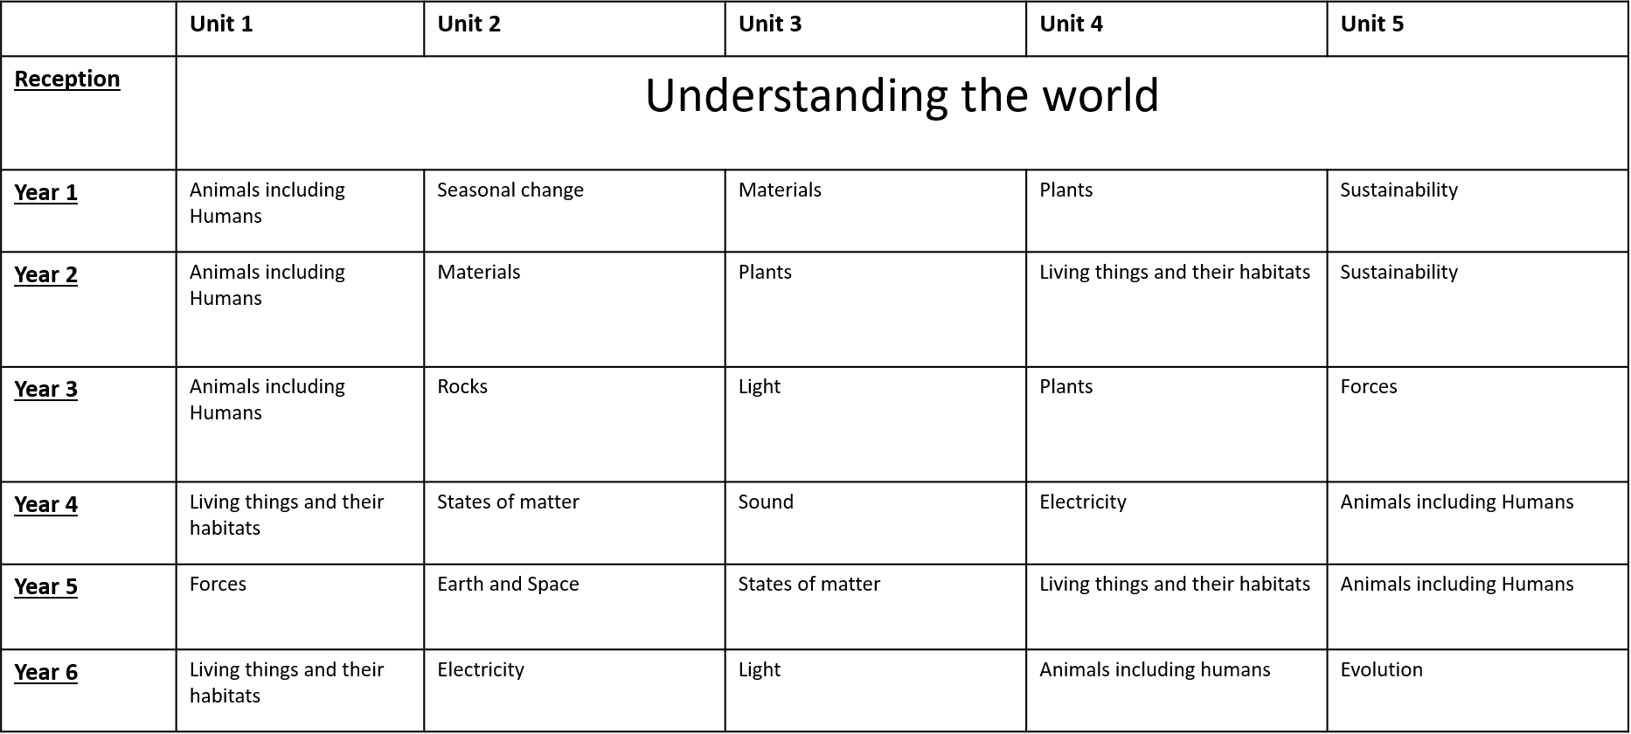

EYFS

In EYFS, Science is linked to the area ‘Understanding the World’. It involves exploring the natural world around them, understanding the similarities and differences and contrasting environments, drawing on their experiences and what has been read in class. In addition, children need to understand some important processes and changes in the natural world around them, including the seasons and changing states of matter.

Planning and Assessment

Teachers plan weekly lessons from the knowledge organisers and the North Mead Learning challenges. Assessment is based on observation of children in lessons and through the evidence in their books. Assessment is based on:

* Scientific knowledge
* Scientific skills

Teachers will ensure the content of the knowledge organisers is taught, this can be evidenced in science books and floor books. Teachers will have knowledge of what has come before so that the children will remember previous learning to support them in knowing more through each topic.

Teachers will use the knowledge organisers to assess the children at the end of each topic. The children will be levelled BLW, WTS, EXS or GDS. Assessment by the class teacher will involve observation, discussion and completed work.

Inclusion

All children are expected to be taught a high-quality science curriculum as part of the wider curriculum. Teachers are expected to use the knowledge organisers and adapt them for the SEND children in their class.

Monitoring and Reviewing

At regular times across the year, the Science Leader will undertake book looks; drop ins and discussions to monitor the effectiveness of our science provision.

The monitoring of the standards of children’s work and the quality of teaching in science is the responsibility of the subject leader. The Curriculum Leader provides a strategic lead and direction for science in the school. The science leader is responsible for supporting colleagues in their teaching of science and for keeping them informed about current developments in the subject. The science leader gives the principal and governors a summary report each year, in which they evaluate the strengths and weaknesses in the subject, and indicate areas for further improvement.

Safety Guidance  
General safety is the class teachers’ responsibility. All teachers are responsible for the safety arrangements for their class and must demonstrate the safe use of equipment.